|  |  |
| --- | --- |
| **Name** | **ID** |
| **Atef Magdy Mitwally** | **20170136** |
| **Abdulrahman Bahig Mahmoud** | **20170143** |
| **Ibrahim Ramadan Abdu** | **20170002** |
| **Ahmed Sayed Mansour** | **20170022** |
| **Hatem Sayed Ali** | **20170084** |

­

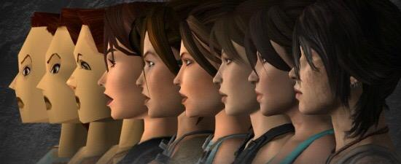

**Cairo University**

**Faculty of Computers**

**and Artificial Intelligence**

Under the supervision of

**Dr. Reda Abdel Wahab**

**Advanced topics in**

**Computer graphics**

Contents

Introduction 2

Object Modeling 2

2D Modeling 2

3D Modeling 3

GPU Rendering 3

GPU Definition 3

GPU Mechanism 4

Comparison between GPU and CPU 4

Visual Realism 4

Definiton of Visual Realism 4

Visualization methods 5

Realism Application 6

Animation and Capture 6

Animation Definition 6

Definition of Motion Capture 7

Motion Capture and Animation character 8

Ray Tracing 8

Mechanism of Ray Tracing 8

Applications of Ray Tracing 9

Conclusion 10

Reference 10

**List of Figures**

Figure.1 (2D object) 2

Figure.2 (3D object) 3

Figure.3 (No Lines Removed) 5

Figure.4 (Hidden Lines Removed) 5

Figure.5 (Hidden Surfaces Removed) 5

Figure.6 (Applications of Realism) 6

Figure. 7 (Animation image) 6

Figure.8 (Motion Capture) 7

Figure.9 (Capture and Animation) 8

Figure.10 (Ray Tracing mechanism) 8

Figure.11 (Ray Tracing in Games) 9

**Introduction**

Computer graphics is a branch of computer science; it is the representation and manipulation of image data by a computer with help from specialized software and hardware. The development of computer graphics has made computers easier to interact with, and better for understanding and interpreting many types of data as it adds color, excitement, visual stimulation to media and focuses on communicating a message visually. It is easier to read it rather than listening to a set of numbers and trying to make sense of it.

Today, computer graphics is a core technology in digital photography, cell phone, cartography,

visualization of measurement data (2D and 3D), visualization of computer simulations, medical diagnostics, drafting and computer design, preparation of publications, special effects in movies and computer games.

**Object Modeling**

**2D Modeling:**

The two-dimensional object modeling is the computer-based descent of digital images

(such as 2D geometric models, text, and digital images), it's started in the 1950s, it’s started based on Vector graphics devices, later its replaced with raster-based devices.

The two-dimensional modeling is not a representation of a real-world object, it's developed to traditional usages such as printing and drawing technologies, such as technical drawing and advertising.

The two-dimensional model is preferred, due to the fact it offers extra direct control of the modeling than 3D modeling.

2D modeling is made by mathematical functions and equations and can be modified and manipulated by two-dimensional geometric transformation such as translation, rotation, scaling.



Figure.1 (2D object)

**3D Modeling:**

3D modeling is a 2D plus the addition of extra primitives, it's a mathematical representation of any three-dimensional object. It is a representation of a real-world object unlike 2D,

3D technique used in computer graphics for producing a 3D digital representation of any object or surface.

It is becoming an integral part of many human activities it's used in various mediums such as video games, movies, architecture (Building design), engineering, commercial advertising, and game development.

Every year, there are more and more methods to use this type of modeling.

3-D modeling software produces a model through many tools and approaches including:

spline curves: smooth shapes described by bezel curves, which are especially computationally complex.

simple polygons: shapes, such as pyramids, cubes, spheres, cylinders, and cones.



Figure.2 (3D object)

**GPU based rendering**

**What is the GPU?**

The GPU (Graphics Processing Unit) it's on the graphics card. Its primary mission is to process data into images on the screen in a fast way because

it's connected to the rest of the computer via AGP which has the responsibility to send data from the computer t the graphic card fast but slow in other.

**How it works?**

A GPU render engine, is an engineered program based on such disciplines as light physics, mathematics, visual perception

And it focuses on the speed of image rendering processes.

**Why we use GPU instead of CPU?**

Comparing to CPU the GPU they do their missions on parallel processing (working with lots of data at the same time).

They share their processes instruction across many cores, but GPU has more cores than CPU.

To see the real difference let's compare them with numbers:

CPU can work on about 24 blocks of data at once, while a GPU can handle 3000 or more.

For example, if we are rendering FHD frames made up of 3 million pixels, it’s the difference between processing 24 or 3000 of those pixels at the same time. It's a big difference in performance.

So, it’s obvious that GPUs faster than CPUs, it's done the work that used to take hours, completed in minutes, BUT only for some tasks,

GPUs designed to render on specific render software packages like Chaos Group's VRay Next,

Otoy's Octane Render and Maxwell Render and 3D rendering is the exact task a GPU is designed for.

A lot of VFX software uses GPU rendering.

And it gained more popularity as its lower hardware costs.

**Visual Realism**

Visual Realism is an approach for translate picture data fed into a computer and for making pictures

which appears to people as a photo rather than computer-generated from complex multidimensional data sets.

Visualization types can be:

-Visualization in geometric modeling.

-Visualization in scientific computing.

Visualization in geometric modeling is advantageous in finding relationships in the design applications. By use the techniques of shading the parts with various shadows, colors, and transparency.

In the design of complex surfaces shading with different structural characteristics can use to find any unneeded quick modifications in surface changes.

VR significant in applications such as computer graphics rendering and photo retouching.

CAD (Computer-aided design) uses perspective and orthographic projection for making rich visual images with all its information.

Model clean-up process produce orthographic views, remove hidden lines, changing necessary hidden lines as dashed line or adding dimension to the different views.

**Existing visualization methods are:**

-Parallel projections

-Perspective projection.

-Hidden line removal

-Hidden surface removal

-Hidden solid removal

-Shaded models

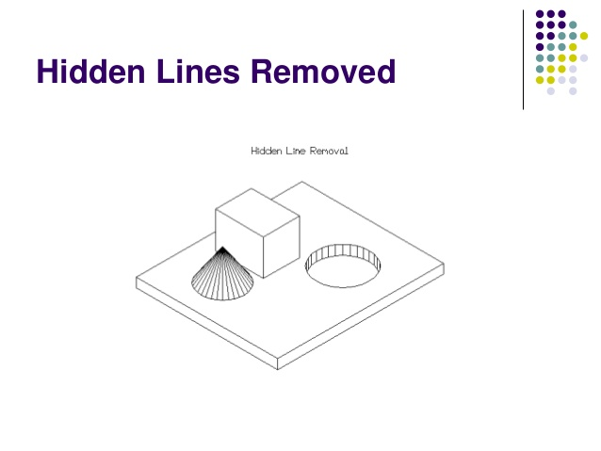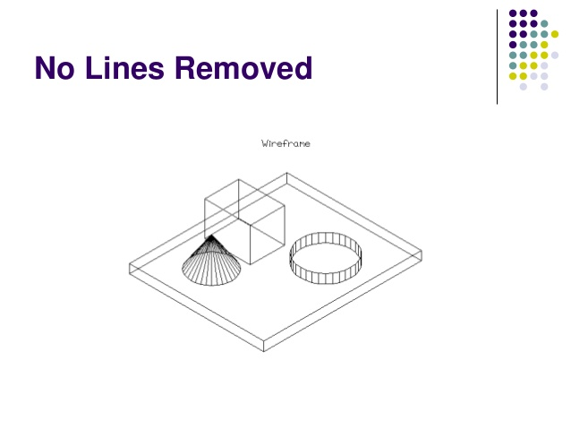And there is an example:

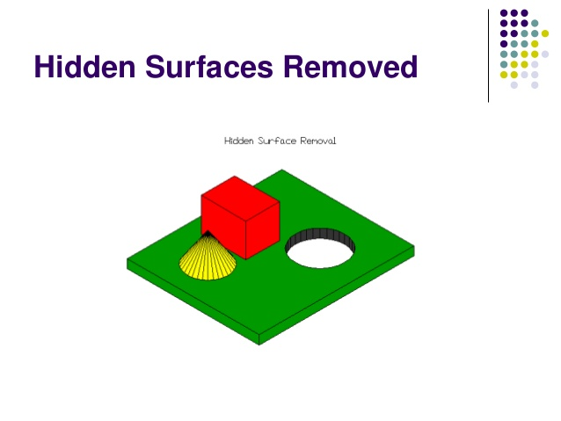Figure.3 (No Lines Removed) Figure.4 (Hidden Lines Removed)

Figure.5 (Hidden Surfaces Removed)

**Application of Realism:**

-Robot Simulations: Visualization of their movement.

-Discrete Event Simulation: Most of DES packages provide to create floor environment on the screen to visualize the layout of facilities, movement of material, performance of machines and tools.

-Scientific Computing: Visualization of results like iso-stress, deformed shapes and stress contours, Temperature.

-Flight Simulation: training for pilots is being provided with flight simulators.

- Medical Purpose.

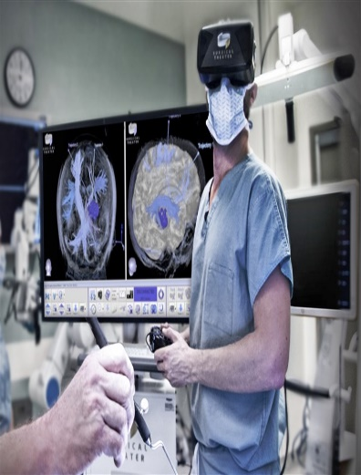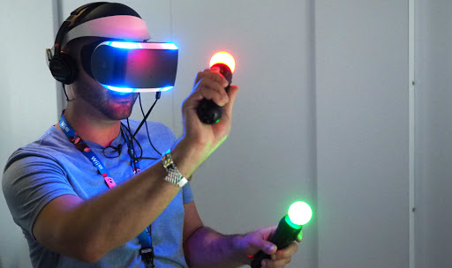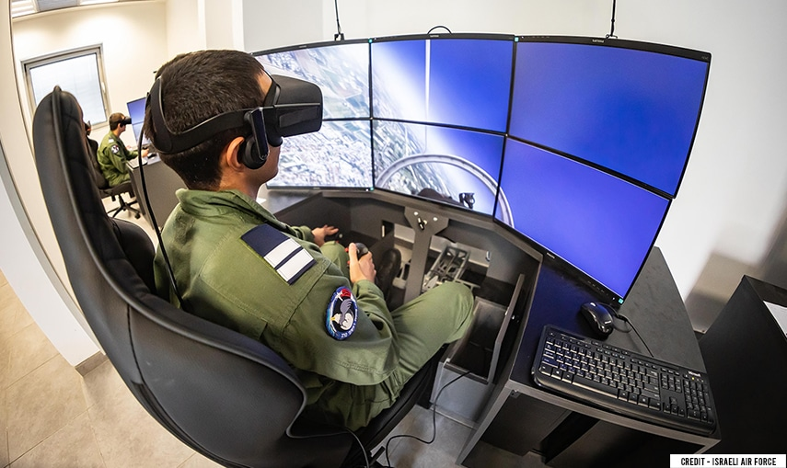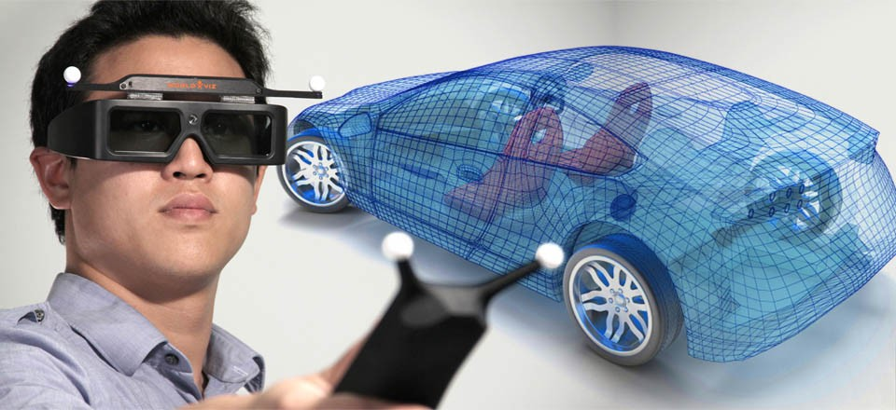-Video Games.

Figure.6 (Applications of Realism)

**Animation and capture**

**What is animation?**

Word "animate" comes from a Latin verb "animate" which means to make a life to fill with breath.

Animation is the fast display of a sequence of images to produce an illusion of movement.

The most common technique of presenting animation is as a motion picture or video program.

shortly; animation means giving life to our imagination.

Types of Animation Techniques

2D animation

3D animation

Traditional animation

Typography Animation

Flipbook Animation, etc.

Figure.7 (Animation image)

**What is motion capture?**

Motion capture, is a technique of digitally recording movements for bodies in many fields such as

entertainment, sports, and medical applications.

it's important as a source of motion data for computer animation.

the motion capture computer software records the positions, velocities, angles, accelerations, and impulses, making an accurate digital representation of the motion.

it's helpful in education, training and sports and recently for both cinema and video games.

and more helpful to reduces the costs of animation, which requires the animator to draw each frame.

The combination of both is the motion capture animation character.

Motion Capture character animation: is that the act of recording an actor's movement and applying it to a 3D character.

Doing this by adding markers to the actor's body and let him perform on a stage surrounded by a lot of motion capture cameras.

When multiple cameras see an equivalent marker, it's ready to identify and record the marker's position.

The data is recorded in code, known as "RAW" Motion Data. After taking the needed captures, the desired takes are selected and the data is “Tracked”, Making .C3D files that are ready to be applied to the 3D character. And using some software to convert these files to FBX animation files.

The final step is editing animations files and preparing them for their final format.

Motion capture can accurately capture which "difficult to model" physical movement.

It can take fewer hours of work to animate a character.

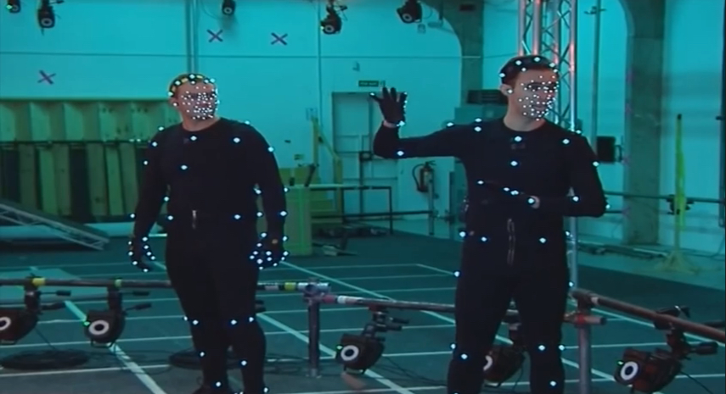

Figure.8 (Motion Capture)

**Motion Capture and Animation character**

Animation and capture make a good combination with each other in many fields BUT there is a difference between them:

Motion capture is different from the process of creating animation for example,

motion capture could also be finished a spread of reasons besides animation, like biomedical analysis, surveillance, sports performance analysis, Each of those tasks

has the same and differences with the problems of creating animation.

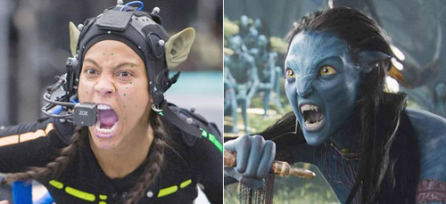the methods utilized in animation have their roots within the biomechanical or medical domains.

Figure.9 (Capture and Animation)

**Ray Tracing**

**What is ray tracing and how it works?**

Ray tracing is a graphic technique used in rendering that can produce incredibly realistic lighting effects. Essentially, an algorithm can trace the path of light as the way light works in the real world,

and then simulate the way that the light interacts with the objects.

It might be absorbed by a dense, dark object, or almost entirely reflected by a mirror.

the light may reflect from one object to a different (causing reflections), be blocked by objects (causing shadows), or undergo transparent or semi-transparent objects (causing refractions).

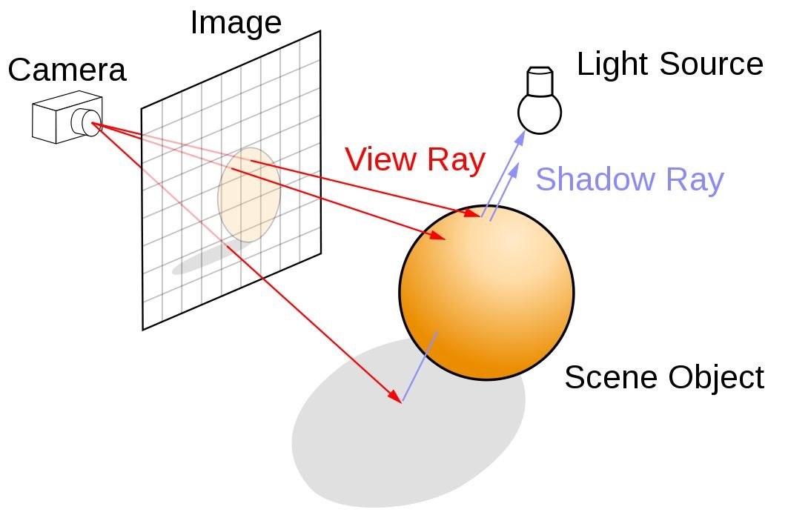

Figure.10 (Ray Tracing mechanism)

All these interactions are combined to produce the final color of a pixel that then displayed on the screen to make you feel like you are actually there. it ultimately hits in the computer-generated world.

Ray tracing is used extensively when developing computer graphics imagery for films and TV shows, and games and etc.

While ray tracing has been "the future" or the important core of computer rendering,

we see it in many games nowadays, and seeing the advent of consumer GPUs which have enough compute capability to do interesting ray tracing workloads in real-time.

It's gives to the game a new life it gives dramatically more lifelike shadows and reflections, along with much-improved translucence and scattering.

**Applications of Ray Tracing**

Most ray tracing games now use a mixture of traditional lighting techniques, typically called "rasterization", and "ray tracing"

on specific surfaces like reflective puddles and metalwork. games like "Battlefield V".

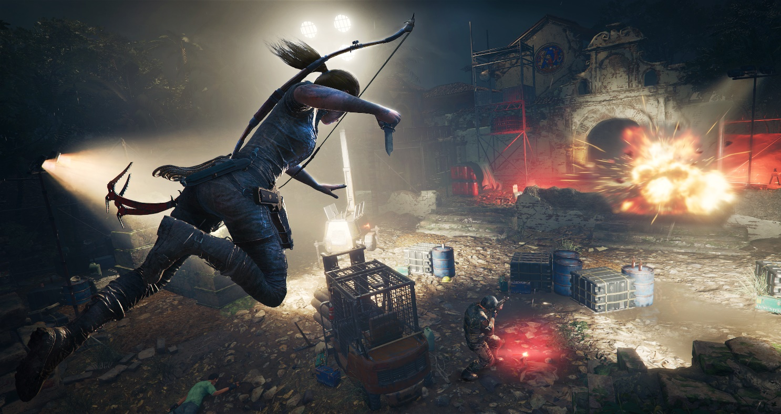

Figure.11 (Ray Tracing in Games)

Ray tracing also used in fields such as animation creations it's used to add illusion effects such as reflection and shadowing that are often difficult and time-consuming for traditional artists to produce. it's also rendering realistic images that would be nearly impossible to produce without using ray tracing.

**Conclusion**

Graphics are greatly important and they are a necessary part of video games. However, the true value of visual is not in their realism. Its aesthetic does much more to determine its character than its polygon count. Switching from the black and white 8-bit games to high rendered 3D games, video games pulled knowledge from art, animation, and the advancing technology to improve its graphics as time went by. There is never any harm in attempting new techniques of game graphics to enhance the development that spanned in half a century to rest on ever richer heritage. Although game graphic has come a long way, it may perhaps even transcend our perception of reality as the technology advances and leans into virtual and augmented reality.

**References**

[1]"2D computer graphics", Computer Graphics, 2020. [Online].

Available: <https://graphics.fandom.com/wiki/2D_computer_graphics>.

[Accessed: 11- May- 2020]

[2]"3D computer graphics", ScienceDaily, 2020. [Online].

Available: <https://www.sciencedaily.com/terms/3d_computer_graphics.htm>.

[Accessed: 10- May- 2020]

[3]"What is 3D Modeling & What's It Used For?", Concept Art Empire, 2020. [Online].

Available: <https://conceptartempire.com/what-is-3d-modeling/>

[Accessed: 11- May- 2020]

[4]"What is 3D Modeling? A Brief Guide | Architectural CGI", ArchiCGI, 2020. [Online].

Available: <https://archicgi.com/blog/product-cgi/3d-modeling-things-youve-got-know/>.

[Accessed: 11- May- 2020]

[5]"What is 3D modeling? - Definition from WhatIs.com", WhatIs.com, 2020. [Online].

Available: <https://whatis.techtarget.com/definition/3D-modeling>.

[Accessed: 08- May- 2020]

[6]"What is GPU Rendering? Definition and FAQs | OmniSci", Omnisci.com, 2020. [Online]. Available: <https://www.omnisci.com/technical-glossary/gpu-rendering>.

[Accessed: 11- May- 2020]

[7]"GPU Rendering — Blender Manual", Docs.blender.org, 2020. [Online].

Available: <https://docs.blender.org/manual/en/latest/render/cycles/gpu_rendering.html>.

[Accessed: 11- May- 2020]

[8] M. Rimkus, "CPU or GPU Rendering: Which Is Better One?", Blog.cherryservers.com, 2020. [Online]. Available: <https://blog.cherryservers.com/cpu-or-gpu-rendering-which-is-better-one>.

[Accessed: 11- May- 2020]

[9]"Is It Time to Invest in GPU Rendering?", Workstationspecialist.com, 2020. [Online].

Available: <https://www.workstationspecialist.com/blog/Is-It-Time-to-Invest-in-GPU-Rendering/>

[Accessed: 11- May- 2020]

[10] V. Realism, "Visual Realism", BrainKart, 2020. [Online].

Available: <https://www.brainkart.com/article/Visual-Realism_5712/>

[Accessed: 10- May- 2020]

[11]"Motion Capture Animation", Motusdigital.com, 2020. [Online].

Available: <http://motusdigital.com/motion-capture.htm>.

[Accessed: 11- May- 2020]

[12]"The Uses of Animation", Hivestudio.net, 2020. [Online].

Available: <http://hivestudio.net/the-uses-of-animation/?gclid=CjwKCAjw7-P1BRA2EiwAXoPWA-fbcdIDR3kGz63J8eiWCLG3B0TPs-3XpMD97z3lxWYQ5trmo2bTnBoCd9AQAvD_BwE>.

[Accessed: 11- May- 2020]

[13]"Motion Capture for Animation", *Opti Track*, 2020. [Online].

Available: <https://optitrack.com/motion-capture-animation/>.

[Accessed: 11- May- 2020]

[14]"Motion capture", Computer Graphics, 2020. [Online].

Available: <https://graphics.fandom.com/wiki/Motion_capture>.

[Accessed: 11- May- 2020]

[15]"Animation", study.com, 2020. [Online].

Available: <https://study.com/academy/lesson/computer-animation-definition-history-types.html>.

[Accessed: 11- May- 2020]

[16]"20 Different Types of Animation Techniques and Styles", *Webneel.com*, 2020. [Online].

Available: <https://webneel.com/different-types-of-animation-styles>.

[Accessed: 11- May- 2020]

[17]"What Is Ray Tracing? | Digital Trends", Digital Trends, 2020. [Online].

Available: <https://www.digitaltrends.com/computing/what-is-ray-tracing/>.

[Accessed: 11- May- 2020]

[18]"Introducing the NVIDIA RTX Ray Tracing Platform", NVIDIA Developer, 2020. [Online]. Available: <https://developer.nvidia.com/rtx/raytracing>.

[Accessed: 11- May- 2020]